Android Summary

Chapter 1 – You first android applicaiton:
- An activity is an instance of Activity, a class in the Android SDK. An activity is responsible for managing user interaction with a screen of information.
You write subclasses(extends AppCompatActivity) of Activity to implement the functionality that your app requires.
- Widgets are the building blocks you use to compose a UI. A widget can show text or graphics, interact with the user, or arrange other widgets on the screen. Buttons, text input controls, and checkboxes are all types of widgets.
- You can use Tools → Layout Inspector to view Hirarchy of your application – A VERY
GOOD UTILITY!!!
- LinearLayout → ViewGroup → View
You use a LinearLayout when you want widgets arranged in a single column or row.
Other ViewGroup subclasses are FrameLayout, TableLayout, and RelativeLayout, ConstraintLayout.
match_parent - view will be as big as its parent
wrap_content - view will be as big as its contents require
android:orientation – horizontal/vertical – topmost or leftmost (Unless the device is set to a language that runs right to left, such as Arabic or Hebrew. In that case, the first child will be rightmost.)
- Wondering what AppCompatActivity is? It is a subclass of Android’s Activity class that
provides compatibility support for older versions of Android
- To get the activity its UI, you call the following Activity method:
public void setContentView(int layoutResID)
- res directory – means resourses directory (also R.bla.bla – R means Resources)
- Android project view (Figure 1.13) - This view hides the true directory structure
of your Android project so that you can focus on the files and folders that you need most often.
- app → build → generated → source → r → debug → R.java - Because this file is generated by the Android build process, you should not change it. Android Studio maintains a hidden R.java that your code builds against. The R.java file in Listing 1.5 is the one that is generated for your app just before it is installed on a device or emulator.
- Android generated a resource ID for the entire layout and for each string, but it did not generate IDs for the individual widgets in activity_quiz.xml . Not every widget needs a resource ID. To generate a resource ID for a widget, you include an android:id attribute in the widget’s definition.
- Android applications are typically ‘event driven’. Unlike command-line programs or scripts, event-driven applications start and then wait for an event, such as the user pressing a button.
- All of the listeners in this book will be implemented as anonymous inner classes (onClickListener)
- (If your knowledge of anonymous inner classes, listeners, or interfaces is rusty, you may want to review some Java before continuing or at least keep a reference nearby.)
- Context - The Context parameter is typically an instance of Activity ( Activity is a subclass of Context ): QuizActivity → AppCompatActivity → .. → Activity → ...→ Context → …
- The emulator is useful, but testing on a real device gives more accurate results.
- How do the contents of activity_quiz.xml turn into View objects in an application? As part of the build process, aapt (Android Asset Packaging Tool) compiles layout file resources into a more compact format. These compiled resources are packaged into the .apk file.
- You can also create your view classes programmatically in the activity instead of defining them in XML. But there are benefits to separating your presentation from the logic of the application.
- You may, for your own reasons, want to perform builds from outside of Android Studio. The easiest way to do this is to use a command-line build tool. The modern Android build system uses a tool called Gradle
- ./gradlew installDebug – to install apk on the connected device from command line

Chapter 2 – Android and Model-View-Controller:
- see page 35 ‘Genrating getters and setters’ for confige android studio to auto generating
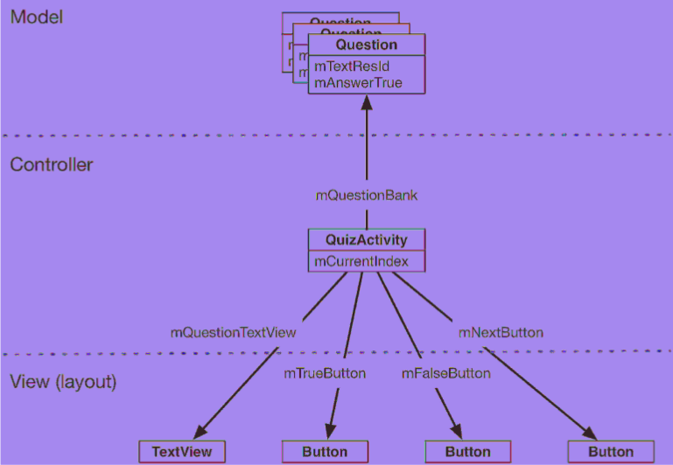
- MVC of GeoQuiz:

- MVC key sentences:
- All objects in your application must be a model object, a view object, or a controller
object
- A model object holds the application’s data and “business logic.” Model objects have no knowledge of the UI; their sole purpose is holding and managing data.
All of the model objects in your application compose its model layer.
- View objects know how to draw themselves on the screen and how to respond to user input, like touches. An application’s view objects make up its view layer.
- Controller objects tie the view and model objects together. They contain “application logic.”
Controllers are designed to respond to various events triggered by view objects and to manage the flow of data to and from model objects and the view layer.
In Android, a controller is typically a subclass of Activity, Fragment, or Service.
- Benefits of MVC:
  - An application can accumulate features until it is too complicated to understand. Separating code into classes helps you design and understand the application as a whole; you can think in terms of classes instead of individual variables and methods.
  - Similarly, separating classes into model, view, and controller layers helps you design and understand an application; you can think in terms of layers instead of individual classes.
  - Although GeoQuiz is not a complicated app, you can still see the benefits of keeping layers separate. In a moment, you are going to update GeoQuiz’s view layer to include a NEXT button. When you do that, you will not need to remember a single thing about the Question class you just created.
  - MVC also makes classes easier to reuse. A class with restricted responsibilities is more reusable than one with its fingers in every pie.
  - For instance, your model class, Question, knows nothing about the widgets used to display a true-false question. This makes it easy to use Question throughout your app for different purposes. For example, if you wanted to display a list of all the questions at once, you could use the same object that you use here to display just one question at a time

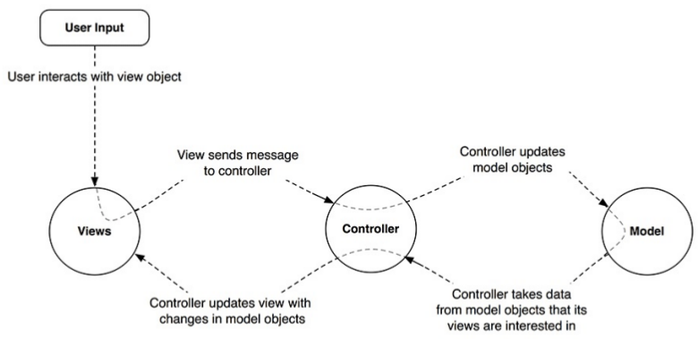

- The suffixes on these directory names refer to the screen pixel density of a device (When the app runs, the OS will determine the appropriate image to display on that particular device):
mdpi medium-density screens (~160dpi)
hdpi high-density screens (~240dpi)
xhdpi extra-high-density screens (~320dpi)
xxhdpi extra-extra-high-density screens (~480dpi)
- If an app runs on a device that has a screen density not included in any of the application’s screen density qualifiers, Android will automatically scale the available image to the appropriate size for the device. Thanks to this feature, it is not necessary to provide images for all of the pixel density buckets. To reduce the size of your application, you can focus on one or a few of the higher resolution buckets and selectively optimize for lower resolutions when Android’s automatic scaling provides an image with artifacts on those lower resolution devices.
- You can add listener also to TextView because it’s also a view: Button → TextView → View
- Challenge: Replacing to ImageButton. ImageButton → ImageView → View

Chapter 3 – The Activity Lifecycle:
- Every instance of Activity has a lifecycle. During this lifecycle, an activity transitions between four states: resumed, paused, stopped, and nonexistent.
- Activity States:
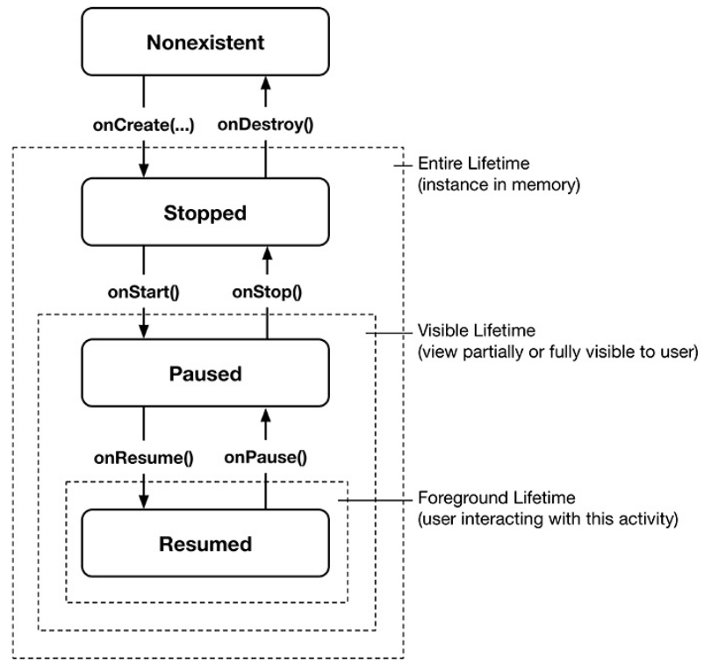
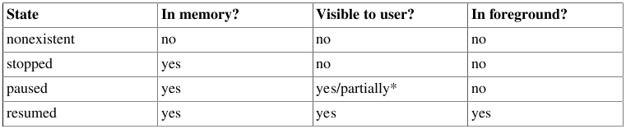
- indicates for each state whether the activity has an instance in memory, is visible to the user,
or is active in the foreground:
- The resumed state represents the activity the user is currently interacting with. Only one activity across all the apps on the device can be in the resumed state at any given time
- Subclasses of Activity can take advantage of these methods named in to get work done at critical transitions in the activity’s lifecycle. These methods are often called lifecycle callbacks
- Typically, an activity overrides onCreate(Bundle) to prepare the specifics of its UI:
- inflating widgets and putting them on screen (in the call to ( setContentView(int) )
- getting references to inflated widgets
- setting listeners on widgets to handle user interaction
- connecting to external model data
- It is important to understand that you never call onCreate(Bundle) or any of the other Activity lifecycle methods yourself. You simply override the callbacks in your activity subclass. Then Android calls the lifecycle callbacks at the appropriate time (in relation to what the user is doing and what is happening across the rest of the system) to notify the activity that its state is changing.
- You may have been wondering about the @Override annotation. This asks the compiler to ensure that the class actually has the method that you want to override (as example in case of typo ‘onCreat’).

- Launch GeoQuiz again by clicking the GeoQuiz app icon. Android creates a new instance of
QuizActivity from scratch and calls onCreate(), onStart(), and onResume() to move QuizActivity from nonexistent to resumed
- The difference between clicking Back button to clicking home button: when clicking home button the function onDestroy() don’t call !! When you pressed the Back button, you told Android, “I’m done with this activity, and I won’t need it anymore.” Android then destroyed your activity’s view and removed all traces of the activity from memory. This is Android’s way of being frugal with your device’s limited resources.
- This is the source of your bug. Each time you rotate the device, the current QuizActivity instance is completely destroyed. The value that was stored in mCurrentIndex in that instance is wiped from memory. This means that when you rotate, GeoQuiz forgets which question you were looking at. As rotation finishes, Android creates a new instance of QuizActivity from scratch. mCurrentIndex is initialized to 0 in onCreate(Bundle) , and the user starts over at the first question.
- Rotating the device changes the device configuration. The device configuration is a set of characteristics that describe the current state of an individual device. The characteristics that make up the configuration include screen orientation, screen density, screen size, keyboard type, dock mode, language, and more.
When a runtime configuration change occurs, there may be resources that are a better match for the new configuration. So Android destroys the activity, looks for resources that are the best fit for the new configuration, and then rebuilds a new instance of the activity with those resources (To fix this bug, the post-rotation QuizActivity instance needs to know the old value of mCurrentIndex . You need a way to save this data across a runtime configuration change, like rotation.)
- FrameLayout is the simplest ViewGroup and does not arrange its children in any particular manner. In this layout, child views will be arranged according to their android:layout_gravity attributes.
- Use onSaveInstanceState for saving mCurrentIndex and then restore it on onCreate(). Note that the types that you can save to and restore from a Bundle are primitive types and classes that implement the Serializable or Parcelable interfaces. It is usually a bad practice to put objects of custom types into a Bundle
- How does the data you stash in onSaveInstanceState(Bundle) survive the activity’s death? When onSaveInstanceState(Bundle) is called, the data is saved to the Bundle object. That Bundle object is then stuffed into your activity’s activity record by the OS.
- Overriding onSaveInstanceState(Bundle) is not just for handling rotation or other runtime
configuration changes.
- onSaveInstanceState(Bundle) called before onStop()

Chapter 4 – Debugging Android Apps:

- Android Lint (or just “Lint”) is a static analyzer for Android code. A static analyzer is a program that examines your code to find defects without running it. Lint uses its knowledge of the Android frameworks to look deeper into your code and find problems that the compiler cannot. In most cases, Lint’s advice is worth taking. Lint can also perform type-
checking for objects that are defined in XML.
- You can manually run Lint to see all of the potential issues in your project, including those that are not as serious as the one above. Select Analyze → Inspect Code... from the menu bar. You will be asked which parts of your project you would like to inspect. Choose Whole project and click OK . Android Studio will now run Lint as well as a few other static analyzers on your code.
- View → Tool Windows → Android Profiler – replaced the ‘Allocation Tracker’ on the new version of Android Studio.

Chapter 5 – Your Second Activity:

- Notice the special XML namespace for tools and the tools:text attribute on the TextView widget where the answer will appear. This namespace allows you to override any attribute on a widget for the purpose of displaying it differently in the Android Studio preview. Because TextView has a text attribute, you can provide a literal dummy value for it to help you know what it will look like at runtime. The value “Answer” will never show up in the real app. Handy!
- When an activity calls startActivity(Intent) , this call
is sent to the OS.
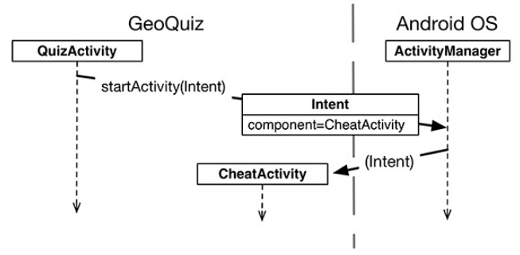

- An intent is an object that a component can use to communicate with the OS. The only components you have seen so far are activities, but there are also services, broadcast receivers, and content providers. Intents are multipurpose communication tools, and the Intent class provides different constructors depending on what you are using the intent to do.
- Before starting the activity, the ActivityManager checks the package’s manifest for a declaration with the same name as the specified Class . If it finds a declaration, it starts the activity, and all is well. If it does not, you get a nasty ActivityNotFoundException , which will crash your app. This is why all of your activities must be declared in the manifest.
- When you create an Intent with a Context and a Class object, you are creating an explicit intent. You use explicit intents to start activities within your application. When an activity in your application wants to start an activity in another application, you create an
implicit intent. You will use implicit intents in Chapter 15.
- You will send this value as an extra on the Intent that is passed into startActivity(Intent)
- Extras are arbitrary data that the calling activity can include with an intent. An extra is structured as a key-value pair, like the one you used to save out the value of mCurrentIndex
in QuizActivity.onSaveInstanceState(Bundle)
- Note that Activity.getIntent() always returns the Intent that started the activity. This is what you sent when calling startActivity(Intent).
- When you want to hear back from the child activity, you call the following Activity method:
public void startActivityForResult(Intent intent, int requestCode)
The first parameter is the same intent as before. The second parameter is the request code. The request code is a user-defined integer that is sent to the child activity and then received back by the parent. It is used when an activity starts more than one type of child activity and needs to know who is reporting back.
- Setting result codes (setResult function on child activity) is useful when the parent needs to take different action depending on how the child activity finished.
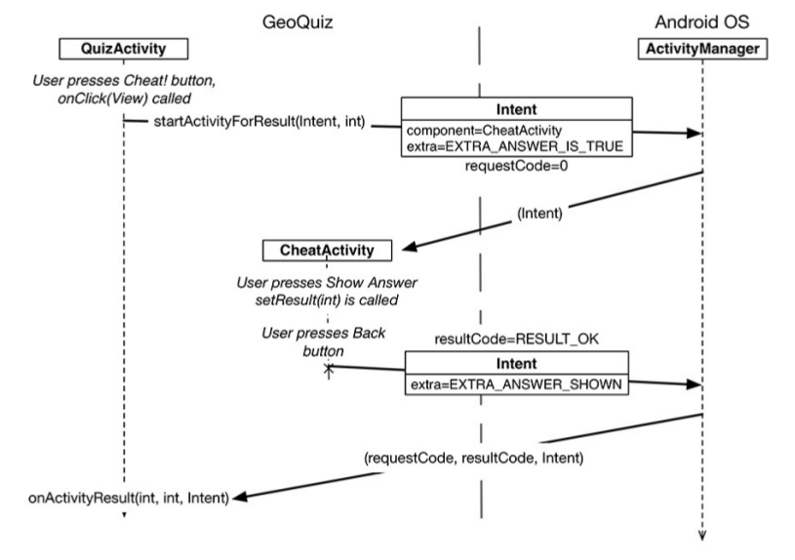
- When you click on the GeoQuiz app in the launcher, the OS does not start the application; it starts an activity in the application. More specifically, it starts the application’s launcher activity. For GeoQuiz, QuizActivity is the launcher activity.
- Stack of activities:
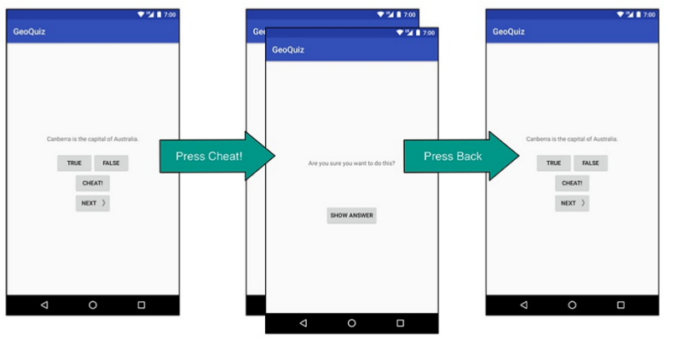

Chapter 6 – Android SDK Versions and Compatibility:

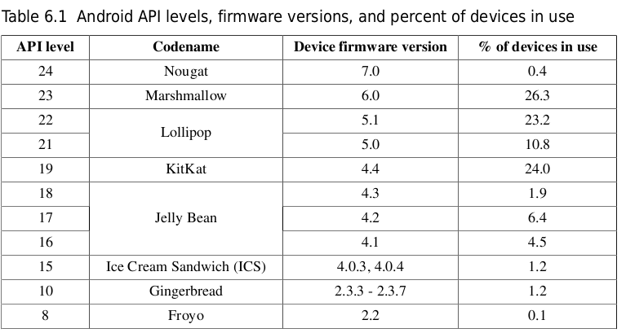
- All of these properties(minimum SDK version, target SDK version, build version) are set in the build.gradle file in your app module. The build version lives exclusively in this file. The minimum SDK version and target SDK version are set in the build.gradle file, but are used to overwrite or set values in your AndroidManifest.xml
- The minSdkVersion value is a hard floor below which the OS should refuse to install the app. By setting this version to API level 19 (KitKat), you give Android permission to install GeoQuiz on devices running KitKat or higher.
- The targetSdkVersion value tells Android which API level your app is designed to run on. Most often this will be the latest Android release.
- The last SDK setting is labeled compileSdkVersion. This setting is not used to update the file. Whereas the minimum and target SDK versions are placed in the manifest when you build your app to advertise those values to the OS, the compile SDK version is private information between you and the compiler. For instance, you might want to
update the build target when a new version of Android is released so that you can make use of the new methods and classes it introduces
- The difference between GeoQuiz’s minimum SDK version and build SDK version leaves you with a compatibility gap to manage. For example, what happens if you call code from an SDK version that is later than the minimum SDK of KitKat (API level 19)? When your app is installed and run on a KitKat device, it will crash (Lint can help to solve this!!). You can see a very good example of an Animator.
- The solutions for the Animator Lint error: A better option is to wrap the higher API code in a conditional statement that checks the device’s version of Android (if (Build.VERSION.SDK_INT >= Build.VERSION_CODES.LOLLIPOP))

- Android development documatation:
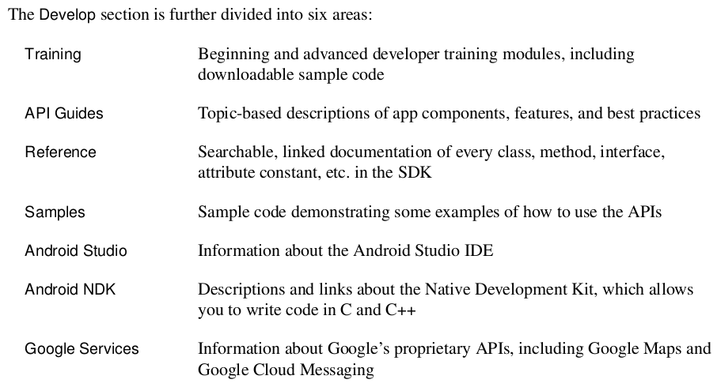

Chapter 7 – UI Fragments and the Fragment Manager:

- In this chapter, you will start building an application named CriminalIntent. CriminalIntent records the details of “office crimes” – things like leaving dirty dishes in the breakroom sink or walking away from an empty shared printer after documents have printed.
- The problems with Activities:
- Imagine that your user is running CriminalIntent on a tablet. Tablets and some larger phones have screens large enough to show the list and detail at the same time – at least in landscape orientation (Figure 7.2).
- Imagine the user is viewing a crime on a phone and wants to see the next crime in the list. It would be better if the user could swipe to see the next crime without having to return to the list. Each swipe should update the detail view with information for the next crime.
- About the previous: What these scenarios have in common is UI flexibility? the ability to compose and recompose an activity’s view at runtime depending on what the user or the device requires. Activities were not built to provide this flexibility.
- A fragment is a controller object that an activity can deputize to perform tasks. Most commonly, the task is managing a UI. The UI can be an entire screen or just one part of the screen.
- A fragment managing a UI is known as a UI fragment. A UI fragment has a view of its own that is inflated from a layout file. The fragment’s view contains the interesting UI elements that the user wants to see and interact with.

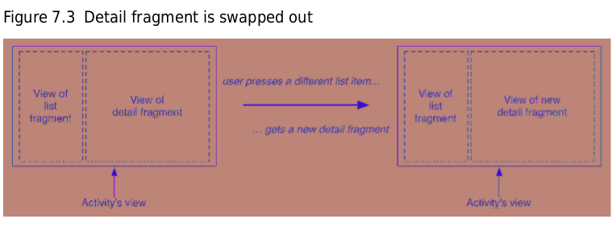
- Using UI fragments separates the UI of your app into building blocks, which is useful for more than just list-detail applications. Working with individual blocks, it is easy to build tab interfaces, tack on animated sidebars, and more.
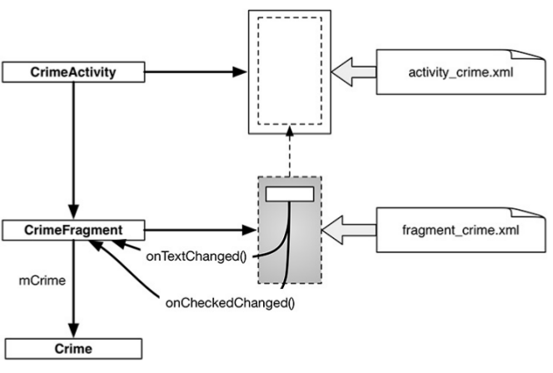
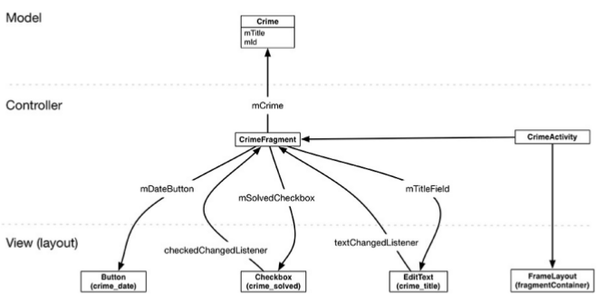

- Fragments were introduced in API level 11 along with the first Android tablets and the sudden need for UI flexibility. You must choose which implementation of fragments that you want use: native fragments or support fragments (In CriminalIntent, you will use the support implementation of fragments).
- To host a UI fragment, an activity must:
- define a spot in its layout for the fragment’s view
- manage the lifecycle of the fragment instance
- Fragment lifescale diagram.
The correspondence is important. Because a fragment works on behalf of an activity, its state should reflect the activity’s state. Thus, it needs corresponding lifecycle methods to handle the activity’s work
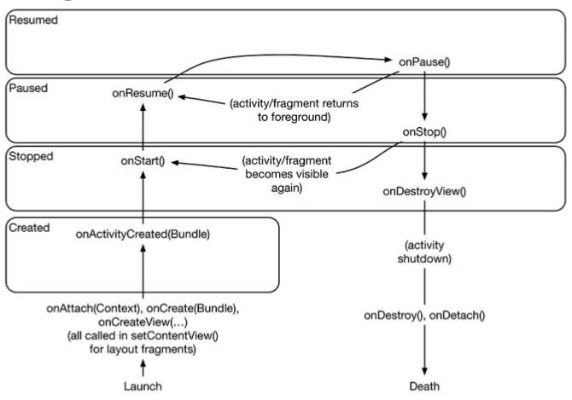

- One critical difference between the fragment lifecycle and the activity lifecycle is that fragment lifecycle methods are called by the hosting activity, not the OS. The OS knows nothing about the fragments that an activity is using to manage things. Fragments are the activity’s internal business.

